HEALTH GOVERNANCE AND TECHNOLOGY

PATIENT FOLLOW UP APPLICATION

CREATED by TEAM 4 from ZOHO CREATOR APP

**(AISHWARYA A, VIGNESH G, PRAKASH V, RAVICHANDRAN, MUZAMIL, SUBAKARAN)**

**PATIENT FOLLOW UP APPLICATION**

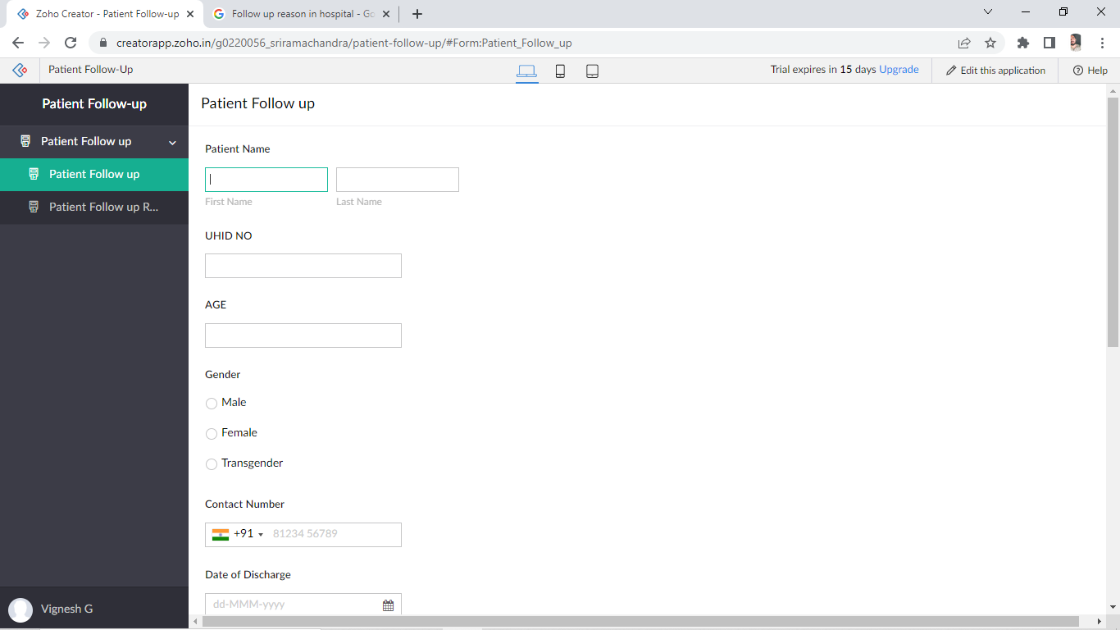

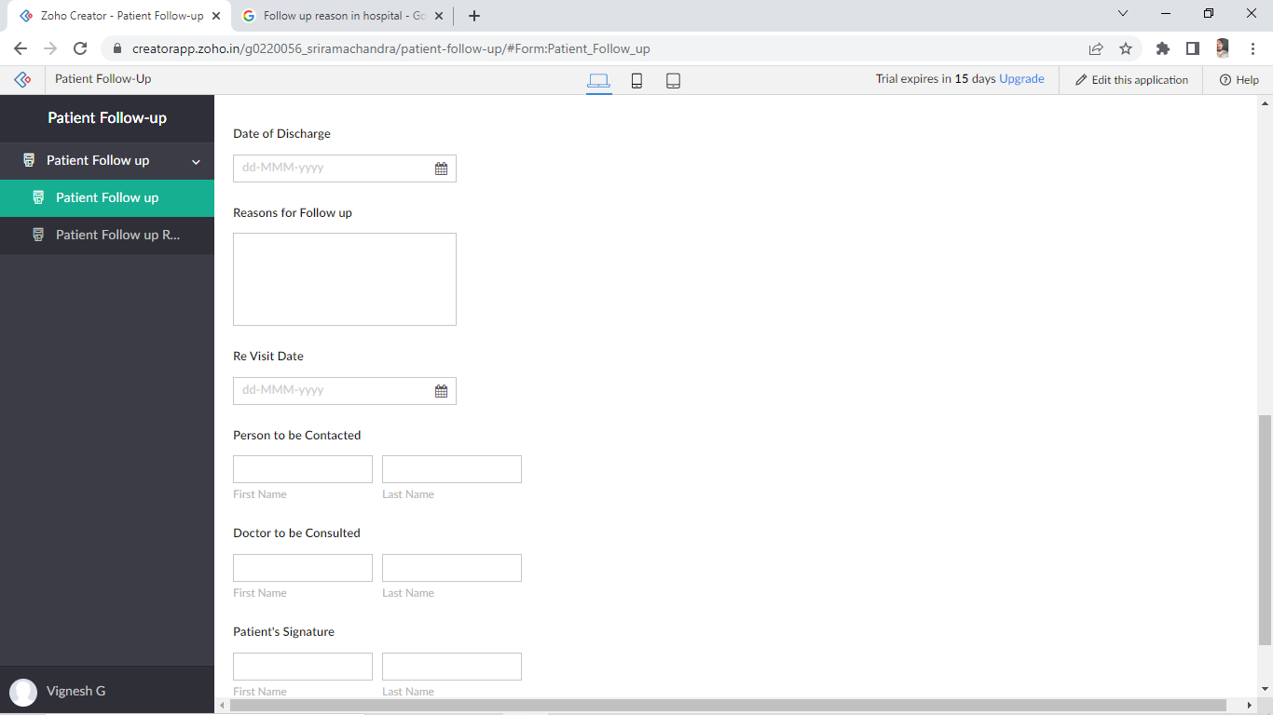

The above is the application developed for Patient follow up from the ZOHO creator app.

LOW CODE /NO CODE software is nothing but anyone can create application form with the help of ZOHO CREATOR.

A person needs not to be skilled in coding. Even with zero knowledge anyone can create app for their own organisation. One has to just drag and drop application components, connect them together and can create mobile or web apps.

This patient follow up will be filled by the nurses on the date of discharge of the patient to schedule the next appointment to revisit the doctor. Once the form is filled up by the nurses, the form is forwarded to the communication department of the hospital who reminds the patient to revisit for their follow up. So with the help of this application, both patient and hospital is benefited. It is like win win situation.

The reason to choose Follow up is, once the patient gets discharged from the hospital it is hospital responsibility to take care of the patients. Care given to a patient over time after finishing treatment for a disease is most important one. Follow-up care involves regular medical check-up; include a physical examination of the patient, blood tests, and imaging tests, to know about their mental health after surgery.

Patient satisfaction lies even on follow up care. It is a major benefit for the hospital, the hospital gets reputed only because of patients feedbacks if the patients are valued and with proper care, the hospital will be able to generate greater profits even in shorter period of time.

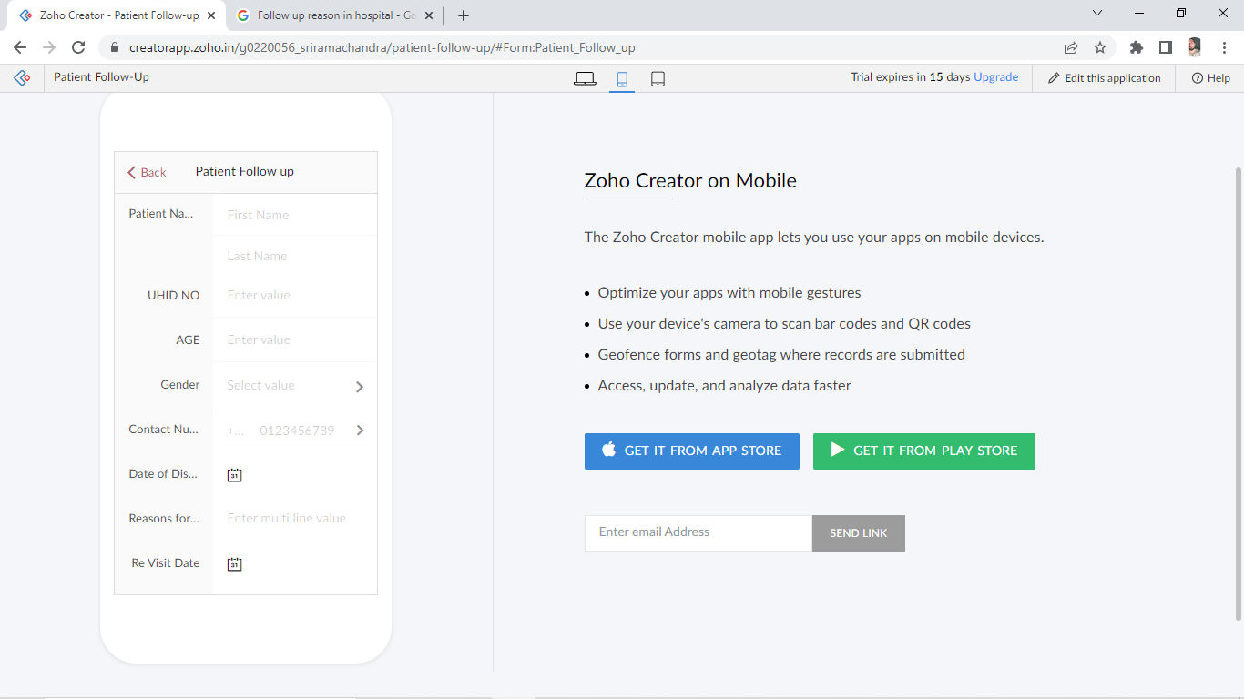

This is the mobile view of the application. The app can be downloaded from the play store and can even access from the mobile.